REINFORCEMENT LEARNING
3. Markov Decision Processes
3.1 The Agent-Environment Interface, Goals and Rewards, Returns, Markov properties, Markov Decision Process, Value Functions and Optimal Value Functions
PAST QUESTIONS:
- Describe the components of an MDP, including states, actions, transition probabilities, and rewards. (M24)
- Enlist components of MDP model and explain in detail? (M25)
- What is optimal policies and explain optimal value function (q*)? (M25)

NOTES:

*Markov Decision Process (MDP) :-
Markov Decision Process (MDP) is a mathematical framework that models sequential decision-making using states, actions, rewards and transitions. In Reinforcement Learning, MDP provides the formal structure that defines the environment and guides how decisions are evaluated over time.
- An MDP consists of an agent that interacts with an environment over a sequence of time steps.
- At each step, the agent observes the current state, selects an action, and receives a reward from the environment.
- The environment then transitions to a new state based on the chosen action, following the Markov property - The Markov property in reinforcement learning states that the future state depends only on the current state and action, not on the history of previous states. This "memoryless" property allows agents to make optimal decisions using only the current state.
- This structured formulation allows Reinforcement Learning algorithms to learn optimal policies that maximise long-term rewards.
An MDP is defined by a 5-tuple:
$$MDP=(S,A,P,R,γ)$$
Where:
- S → Set of States
- A → Set of Actions
- P → Transition Probability
- R → Reward Function
- γ (Gamma) → Discount Factor
Components of MDP –
- Agent: The decision-maker that learns by interacting with the environment to achieve a goal.
- Environment: Everything the agent interacts with, which responds to the agent’s actions by changing states and giving rewards.
- State (S): A representation of the current situation of the environment at a given time.
- Action (A): A choice made by the agent that influences the next state of the environment.
- Reward (R): A numerical feedback signal that evaluates the quality of an action taken by the agent.
Explanation –
1. States
States describe the current situation of the environment and contain all information relevant for decision making.
S={s1​,s2​,…,sN​},∣S∣=N
2. Actions
Actions represent the possible decisions an agent can take to influence the state of the environment.
$$A=\{a_{1},a_{2},…,a_{K}\},∣A∣=K$$
Here, $A$ denotes the finite set of all possible actions and K is the total number of actions.
3. Transition Function
The transition function defines how the environment changes state when an action is taken, capturing the uncertainty in action outcomes. The process is Markovian, meaning the next state depends only on the current state and action, not on past history.
$$P(s_{t+1}∣s_{t},a_{t})=T(s_{t},a_{t},s_{t+1})$$
Here $T(s_{t},a_{t},s_{t+1})$ represents the probability of moving to state $s_{t+1}$ after taking action in state $s_{t}$.
This property ensures that the current state contains all information needed for optimal decision making.
4. Reward Function
The reward function provides a numerical feedback signal that guides the agent toward achieving its goal.
$$R:S×A×S→R$$
Here $R(s,a,s^{'})$ denotes the reward received when the agent takes action a in state s and transitions to state $s^{'}$.
The reward function implicitly defines the learning objective by assigning positive, negative or zero values to outcomes, encouraging desirable behavior and discouraging undesirable actions.
5. Markov Decision Process (MDP)
A Markov Decision Process combines states, actions, transition dynamics and rewards into a single mathematical model for sequential decision making.
$$MDP=<S,A,T,R>$$
This framework can represent both episodic tasks (with terminal or absorbing states) and continuing tasks within the same model.
Value Functions
Value functions measure how good it is for an agent to be in a state or take an action, helping Reinforcement Learning agents learn optimal policies.
1. State Value Function
The state value function represents the expected cumulative reward for starting in a state s and following a policy $π$.
$$V^{π}(s)=E_{π}[\sum_{t=0}^{∞}{γ^{t}}R(s_{t},a_{t},s_{t+1})∣s_{0}=s]$$
It calculates the total expected reward from state s, considering future rewards discounted by $γ$.
2. Action Value Function
The action value function evaluates the expected reward of taking a specific action a in state s and then following policy $π$.
$$Q^{π}(s,a)=E_{π}[R(s,a,s^{'})+γV^{π}(s^{'})]$$
It combines the immediate reward for action a with the discounted value of the next state.
3. Bellman Equations
Value functions are recursive:the value of a state equals the immediate reward plus the discounted value of future states. This principle allows learning algorithms to update values iteratively without needing to simulate all future steps.
State value function:
$$V^{π}(s)=\sum_{s^{'}}{P(}s^{'}∣s,π(s))[R(s,π(s),s^{'})+γV^{π}(s^{'})]$$
Action value function:
$$Q^{π}(s,a)=\sum_{s^{'}}{P(}s^{'}∣s,a)[R(s,a,s^{'})+γQ^{π}(s^{'},π(s^{'}))]$$

These equations express that the value of a state or action equals the immediate reward plus the discounted value of future states.
4. Optimal Value Functions and Policy
Optimal value functions represent the maximum achievable reward, and the optimal policy selects actions that achieve it.
$$\begin{matrix}V^{*}(s) & =\underset{a}{max⁡}Q^{*}(s,a), \\ Q^{*}(s,a) & =\sum_{s^{'}}{P(}s^{'}∣s,a)[R(s,a,s^{'})+γ\underset{a^{'}}{max⁡}Q^{*}(s^{'},a^{'})]\end{matrix}$$
The optimal state value is the best possible return from a state, and the optimal action chooses the action with the highest expected reward.
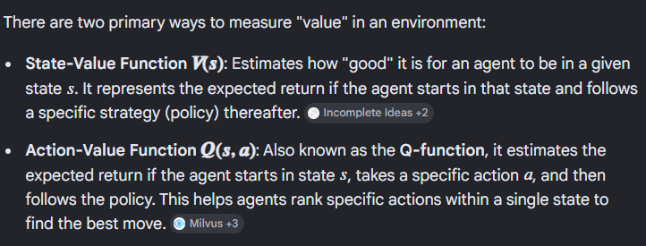

*Optimal Policy :-
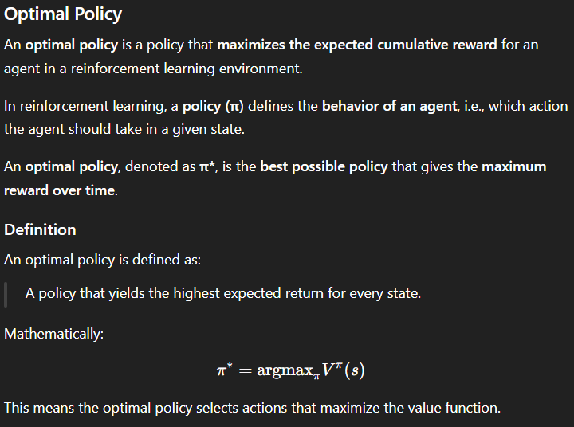
*Optimal Value function :-
The optimal value function q* in reinforcement learning represents the maximum expected cumulative future reward an agent can attain from any state or state-action pair, assuming optimal play thereafter.
